Research

## - How to make a website attractive to teenagers.

The main focus of my website is to be able to offer a wide range of useful GCSE revision material for students who are currently taking subjects such as Maths, Science and English. Therefore the younger audience is the target for the website. This generation is much more tech savvy than previous generations, and their values and styles of navigating, shopping and using the internet have changed. In summary, the ‘Gen Z’ are after a few things: fast and convenient information, content that’s funny and personal, and products and services that focus on their long term goals while also giving them instant gratification.

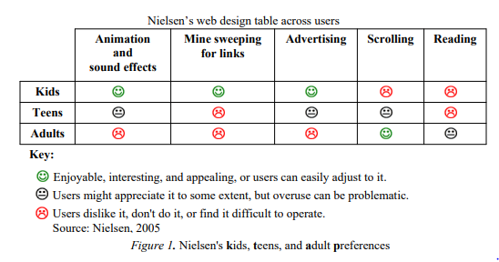Based on this graph from *Source 3*, is fair to assume that teens are one of the most demanding age groups as their requirements from a website are quite high and meticulous.

Do: animation effects eg. Info carousel. This adds a more modern look to the website which is what teens are looking for.

Do: add some scrolling to the page. Some scrolling in the page is necessary as the is a lot of information to share in the website, but I should keep it limited as

Don’t: add advertising.

Don’t: create long texts.